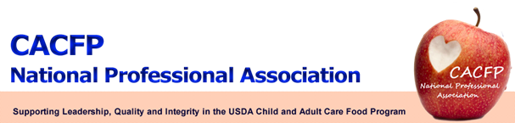

March Message of the Month

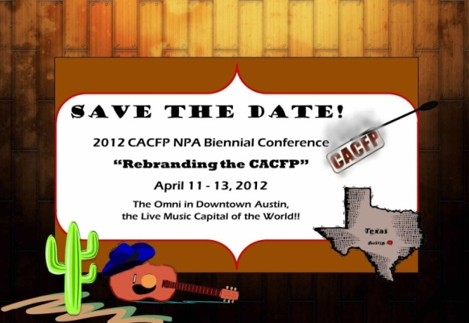2012 CACFP NPA Conference – April 11-13, 2012
The conference is almost here! We hope you are as excited as we are. What a great opportunity to network with our peers from other states, and learn about pertinent topics that will help improve the administration of all aspects of CACFP. Sessions include successful grant writing strategies, budgeting and monitoring of FDCH carryover funds, adult training techniques, and nutrition best practices. In addition, Enviromedia, an advertising and PR agency, will present on the place of social media in CACFP and how we can use it to “rebrand” the Program. We look forward to seeing you in Austin!
Registration: Guess what??? You can now register on-line at http://www.cacfpnpa.org. New for this year - attendees can pay the registration fee with PayPal!
We look forward to seeing you in Austin!

Prospective State Exhibitors (This means everyone!): Please share the many wonderful things you’ve done. You may think it ordinary, but another state may think it’s extraordinary. Please contact Benedict Onye at benedict.onye@ct.gov for more information on letting the rest of us experience the benefit of your outstanding work.

CACFP NPA Membership
If you can’t attend the conference, remember, you can still renew your two year membership for 2011-2013. Although the membership form can be found on the CACFP NPA website, for a direct link, with no further searching, click here: http://www.cacfpnpa.org/2011-2013%20Membership%20Form%20State%20Agency.doc. The membership form will be at your fingertips and ready to complete and submit. Connie Bell, the Board Treasurer, can answer questions about payment. Contact her at 505-827-9964 or via email at connie.bell@state.nm.us.
There are a lot of perks to being a CACFP NPA member. Members receive a conference discount as well as a monthly newsletter to keep them updated on important topics. Also, don’t forget our wonderful updated website! If you haven’t yet taken a look, you should. We’ve gone from blah  to wow ! Keep an eye out for more on-line member perks in the future.

USDA Updates

- If you missed the February 22, webinar on how to use Census data to determine eligibility in CACFP and SFSP, it is now in PartnerWeb.
- Find a copy of the recently released OIG audit of CACFP at www.usda.gov/oig/webdocs/27099-0001-DA.pdf . The title of the audit is Identifying Areas of Risk in the Child and Adult Care Food Program (CACFP) Using Automated Data Analysis Tools.
- And did you know the USDA policy memos go public within three days of being posted to PartnerWeb?

